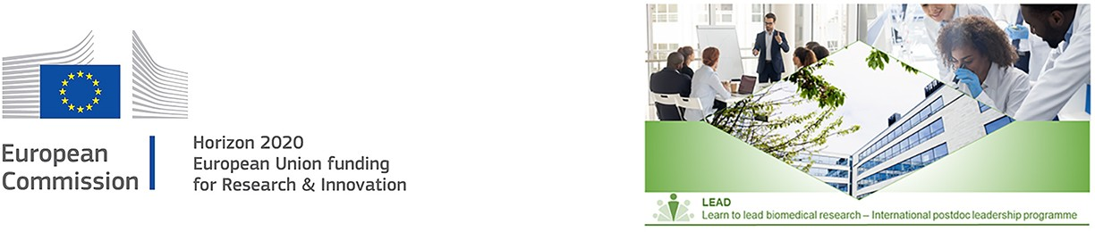

CV
Do not exceed 4 pages for your CV- excess pages will not be taken into consideration by the experts Please respect the following:
- a minimum font size of 11 points
- single line spacing
- margins (top, bottom, left, right) of 2 cm (not including any footers or headers)
- a clearly readable font (e.g. Arial or Times New Roman)

Personal information

Name:
Gender:
Nationality Date of birth:
E-mail address:
Researcher ID (ORCID):

- Scientific bio sketch (maximum 400 words)
Include research focus and short and long-term career perspectives.

Education
Include your MSc or MD as well as PhD-degree. Include affiliations, dates of obtained degrees, thesis titles, and supervisor names.

Current and previous positions
Include your most recent positions held (in reverse chronological order). Please include any career breaks if applicable (reason and duration)

Fellowships and awards
Outline any current and previous grants and fellowships

Scientific communication
E.g. Posters, talks at a conference, invited presentations

Major collaborations and international experience
Outline the major collaborations including your role and the output

Teaching and supervision
E.g. supervision of master students, teaching assistant

Institutional responsibilities and project management
E.g. Graduate student representative; Organizer of an internal seminar/meeting

Other relevant activities
E.g. grant writing experience, technology transfer activities, outreach and public communication activities

List of publications

  - No page limit on your list of publications
  - List your peer-reviewed publications in reverse chronological order
  - Include journal impact factors and the number of citations (excluding self-citations)
  - Include description of contribution to the publication and impact/results of publication.
  - If applicable also include other contributions such as patents and non-peer-reviewed publications.

